

**UNDERGRADUATE PROJECT(SLIIT)**

Assessment 01: Reflective Report

**Implementation of a Mobile Application that helps Users to Relieve Workplace Stress and Improve Mental Wellbeing**

BSc (Hons) Computer Science & Software Engineering

University of Bedfordshire

**Sahan Sudaraka Rathnayake**

**1916390**

Table of Contents

**01.** **Introduction** 1

**02.** **Self Management** 1

**02.1.** **Topic Selection and Used Technology** 1

**02.2.** **Supervisor Feedbacks** 1

**03.** **Communication and Quality of the Report** 2

**04.** **Reflection** 2

**04.1.** **Current Progress** 2

**04.2.** **Future Work** 4

**04.3.** **Good practices and Drawbacks of the project** 4

**04.4.** **Recommendations for future Researchers** 4

**05. Detailed thesis content** 4

# **Introduction**

The proposed project is about existence of workplace stress of employees and catering a modern solution for this through a mobile application. The project looks into Artificial Intelligence technology which enhance the productivity and the effectiveness of the mobile application. Employees can access the system easily since it is a mobile application.

# **Self Management**

## **Topic Selection and Used Technology**

Development of workplace stress in working employees is a common unattended health hazard in almost all of the developing and developed countries. This is resulted due to many stressors causing stress like workload, overtime, time pressure, poor posture etc. Since the issue seems to be increasing worldwide needed attention and a solution. After carrying out a proper market research and a literature review problem seemed to be getting worse by the day. As a solution for this researcher proposed a mobile application which helps in reducing workplace stress.

Since the proposed system is a mobile application Android Studio is used as the developing platform. Java is used as the developing language. SQLite will be used to implement the database. In addition, Artificial Intelligence techniques will be used to make the application smarter.

## **Supervisor Feedbacks**

Supervisor feedbacks has made the flow of the project nice and smooth. Through the guidance obtained from the feedbacks, could achieve the time goals. In the first meeting with supervisor only had a slight idea to a research which developed into a detailed research idea through the feedbacks obtained.

First objective as set by the supervisor was to find the factors causing the workplace stress by going through previously done research articles. Next idea was to conduct a market research with a questioner to find out existence of the workplace stress as a health hazard in the society. Market research was carried out collecting data from more than 800 employees. Then the data was analyzed according to the guidance received by the supervisor. Next goal was to finalize system functions. As discussed with the supervisor mobile application was to implement with the help of Artificial Intelligence techniques which makes the application smarter. Initial idea was to track mood of the employee in the application through a questioner. After discussing with the supervisor that was changed to use emojis to track the mood which makes it more user friendly.

# **Communication and Quality of the Report**

The research structure was initially to come up with a research idea. Next to conduct a literature study on the selected field. Then to collect data through a market research and finding the best solution that can be delivered to the said problem. Then need to implement the solution and test it on a selected group of users.

Since the research address a common problem in the society, there is an added value to the society from the research. Therefore, solution also relevant to the research discussion.

# **Reflection**

## **Current Progress**

Currently research documentation is almost done. Project proposal and contextual report is completed. What is left of documentation is the final thesis. All the facts, details and diagrams needed for the final thesis are in place.

As for the implementation of the system, researcher has started implementing the system. Altogether there are four main functions to be implemented.

* + Mood tracker
  + Sleep tracking system
  + Dashboard
  + AI chatbot

Mood tracker is completely implemented and ready for testing purposes. Mood tracker is implemented so that the mood is tracked using emojis. Dashboard implementation is underway and progressing in a considerably good pace.

As shown in the below fig 1. Mood tracker interface uses user friendly emojis to track everyday mood of the employee. And in fig2. a code is illustrated which is used to add a comment to the mood of the employee.

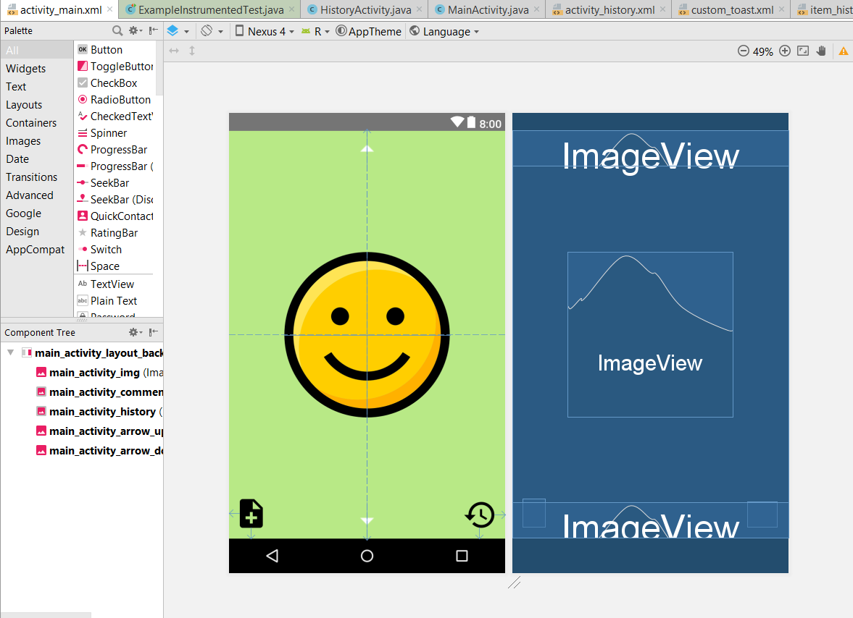

**Figure 1 Mood Tracker Interface**

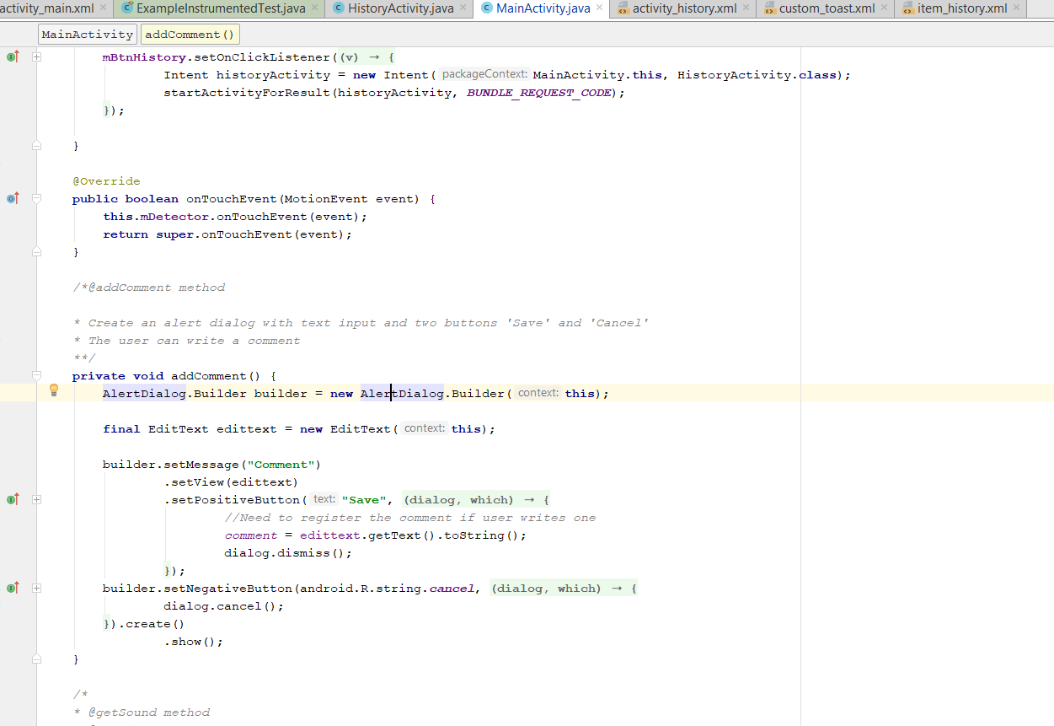

**Figure 2 Code Segment for Saving Mood Status**

## **Future Work**

From now on mainly need to focus on the implementation of the system with the finalized functions. After the implementation of the Dashboard, sleep tracker and AI chatbot system needs to be properly tested before released to the users. Along with the system implementation need to work on the Final Thesis report as that’s what is left of documentation.

## **Good practices and Drawbacks of the project**

Before the implementation of the system it is important conduct a literature review on the selected topic. But from the experience, it is more important to conduct a proper market research to get a clear understanding on the field of the research. Since I was able to conduct a market research with a proper set of questioners and was able to gather data from 800+ employees, I was able to get a proper understanding of the problem and of the solution needed. And furthermore, since I was able to finalize system functions in the beginning, a clear understanding of the final end product was obtained from the beginning.

As for the main drawback was it was late when the system implementation was started. As a good practice it’s better to start the system implementation along with the project documentation. Then it will save time for a better testing process when the project is tight.

## **Recommendations for future Researchers**

The proposed application is smarter than other existing application since it uses AI techniques. But it will be smarter if image processing techniques are also used. In this application mood is tracked through user feedbacks. But instead of that mood can be tracked using front camera of the smartphone through image processing. This feature will make the application even more user friendlier.

# **05. Detailed thesis content**

* Title page
* Abstract
* This part will include a summary of the project
* Acknowledgment
* Vote of thanks for each and every individual who helped me in each and every way in guiding to win all the obstacles in the completion of the project
* Dedication
* To offer warmest gratefulness to whoever need to be honored.
* Table of contents
* List of figures
* List of tables

**Chapter One: Introduction**

* 1. Background to the project

This part will include the background story to the project. This will include ho the idea was developed to conduct a research on the selected topic.

* 1. Project Aims and Objectives

What I wish to achieve at the end of the project and what are the possible outcomes in doing so.

* 1. Description of the artefact

Detailed description of the final end product will be discussed in this section

* 1. Report structure

Detailed idea about the chapters in the final thesis report

**Chapter Two: Systematic Literature Review**

2.1. Introduction

This section will include an introduction to the literature review

2.2. Workplace Stress

This sub section is for the proper literature review of the workplace stress.

2.3. Factors causing workplace stress

Literature review about the factors causing the workplace stress will be discussed in this section

2.4. Impact of workplace stress

Impact caused to the society and to the individuals due to workplace stress will be critically reviewed in this section

2.5. Similar system review

Similar systems built so far as a solution for the workplace stress will be evaluated in this part.

2.6. Conclusion

Research gap or the highlighting of the research component and discussion about the importance of the research will be done in this section.

**Chapter Three: Methodology**

3.1. Methodology

Methodology selected for the implementation of the project will be discussed in this section.

3.2. Requirement Gathering

Primary and secondary data gathering process will be discussed in this section

3.3. Planning

Planning carried out for the project will be illustrated in this section with the relevant UML diagrams.

3.4. Market Research

Analyzed data of the conducted market research will be discussed in this section

3.5. Design and Implementation

Design phase and the implementation phase of the project will be included in this section with the relevant system diagrams.

3.6. Testing and Evaluation

Performance of the implemented product will be tested and highly evaluated in this section.

**Chapter Four: Results and Discussion**

All the developed functions will be discussed in detail in this section

* + Mood tracker
  + AI chatbot
  + Login and Registration
  + Dashboard
  + Stress reliver tracker
  + Sleep tracker

**Chapter Five: Evaluation**

Critical evaluation of the developed system will be done in this section

**Chapter Six: Conclusion**

6.1. Benefits of the project

Benefits earned by the developed project will be discussed in this part.

6.2. Limitations of the project

Flaws or shortcomings due to the mistakes in the methodology will be discussed in this section.

6.3. Future work and recommendation

Proposed other methods in developing the implemented system and other new features that can be added will be mentioned in this section which gives a head start for the future researchers.

**Chapter Seven: References**